
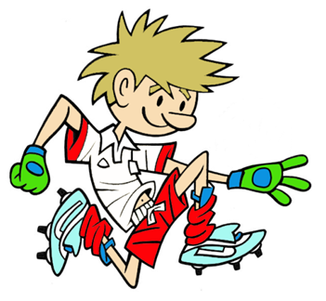

RULES – HOW TO PLAY

Space out 4 cones as shown

Start by lifting 4 quoits from hoop

Run out to cone and place quoits on top of cones

Use nearside hand for placing quoit on cone

Run back and ‘High 5’ (Right hand to right hand with next runner

Next player runs out and takes quoits of cone and places them back in hoop for next runner etc.

STATION 2: AGILITY
Activity: Cap The Cone
FOCUS
Develops child’s ability to change direction at speed and challenges their manipulative skills
FOCUS:

HARDER
- Increase distance between hoop and cones
- Add in more cones and quoits
- Travel by hopping etc.

EASIER
- Replace cones with hoops and place quoits in hoop
- Remove quoits and just run out and touch cones
- Have two players at each end of course

COACHING POINTS

HEAD
- Scan area with eyes and keep head up when running to and from cones
- Keep your eyes on quoit when placing and picking up

HANDS
- Use nearside hand i.e. left hand if cone is on left side

FEET
- Run on balls of feet
- Plant outside foot to change direction and lift with this hand

EQUIPMENT

- 1 Medium Hoop

- 4 Quoits

- 4 Medium cones

Copyright Ulster Council GAA 2009

